**Develop A Web Application Using Node-RED Service**

**Develop The Web Application Using Node-RED**

|  |  |
| --- | --- |
| Date | 27 August 2022 |
| Team ID | PNT2022TMID18337 |
| Project Name | Project - IoT Based Safety Gadget for Child Safety Monitoring and Notification |

**Steps Followed:**

1.Opened a Node-RED project

2.Added code to get child location in python

3.Created the GeoFence

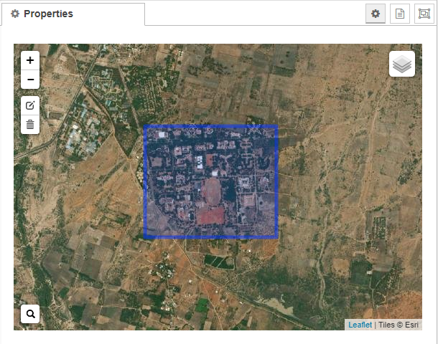

4.Editing the HTTP Request URL

5.Located the child

6.Created the geofence node

7.Python script sending requests to IBM Cloud

8.After running the script, the web UI shows “Person is not in the particular area”

Result:

Successfully developed a web application using Node-RED